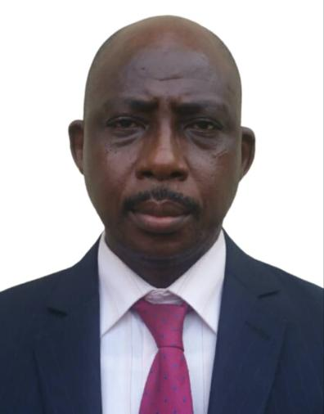
VANGERWUA BARNABAS BEM
CONSULTANT AUDIOLOGIST
Nigerbell Hearing & Speech Centres Ltd 3, Bayo Ajayi Street
Agidingbi, Ikeja Lagos.
Email: drbbvangerwua@gmail.com.ng
bbv@nigerbellhearing.com.ng
Website: www.nigerbellhearing.com
www.otolix.com.ng
Tel: 08023011988
Nationality: Nigerian
State: Benue
Marital Status: Married

Objective: Motivated individual with doctorate in Audiology, masters in Clinical psychology in mission to help carry out organized efforts that ensures the public Hearing and psychological health through audiology.
Passionate about the growth and development of Audiology in Nigeria.
Skills: Audiology, Hearing aids, Cochlear implants, Tinnitus management, Hearing conservation, Geriatric Audiology and Auditory-Verbal Therapy.
Experience:
- Provides rehabilitation for hearing loss and tinnitus
- Maintains continuing education requirements as mandated by the relevant professional bodies.
- Coordinate and manage audiologic care for parents and patients.
- Offer counseling to patients’ parents and family members
- Developing and implementation of Hearing Conservation projects in Aviation, Power &Energy, Oil and Gas industries.
- Offering product training to clinicians on hearing aid fitting (WIDEX, RESOUND & PHONAK) brands, Audiological instrumentation etc. and all other brands represented in Nigeria by our company.
- Excellent communication skills
- Perform diagnostic audiologic evaluations for diverse pediatric and adult patients’ populations.
- Recommendation, selection and fitting of different brands and models of hearing aids.
- Provide Cochlear implant services (MED-EL) brand, which include candidacy evaluation, counseling, recommendation, intra-operative telemetry, mapping, troubleshooting, aural rehabilitation and post implantation measures.
- Impression taking, in-house Ear mould processing in the Laboratory, hearing aid troubleshooting and repairs.
- Performs Otoacoustic Emission tests and Auditory Evoked Potentials (AEPs) tests.
Education:
- PhD Audiology University of Ibadan 2016-2021
- MSc Clinical Psychology University of Lagos 2005-2007
- B. ED Hearing impairment Education University of Jos 1989-1994
Membership:
- Member International Society of Audiology (ISA)
- Member World Health Organization (WHO)
World Hearing Forum (WHF) subcommittee on Safe Listening Group
- Member The Medical Rehabilitation Therapists Board of Nigeria (MRTB)
- Member Representing Africa at the Round Table session on International Best Practices in Audiology at the World Congress of Audiology Warsaw, Poland
- Member Nigerian Speech & Hearing Association (NISHA)
- Member Speech Pathologists and Audiologist Association of Nigeria.

Work History:
- Audiologist Intern 1991-1992 Daato Hearing & Speech Centres Ltd, Lagos
Audiologist 1992-1995 Daato Hearing & Speech Centres Ltd, Lagos
- Audiologist 1995-1997 Eko Hospitals Plc, Ikeja Lagos
- CEO/Audiologist 1997-date Nigerbell Hearing & Speech
Centres Ltd. Otolix Hearing Centres Ltd
(Lagos, Abuja,
Port Harcourt and Calabar)

- Head of Department/ Lecturer 2023 -date Dept of Audiology, Federal University of Health Science
IlaOrangun, Osun state.

Referees:
Professor Wahab Dele Owolawi
Audiologist
Tel: 08083257680

Dr. Michael OlutayoAmosu
ENT Surgeon
Tel: 08023039800

Professor Moji Oyebola
Audiologist/Speech Pathologist
08033285160

Publications:

- The psycho-emotional effects of tinnitus.A case study,Thesis submitted to the Dept of Psychology, University of Lagos for the award of M.Sc degree in Clinical Psychology(,2007)
- Influence of Contralateral Routing of Signal(CROS) hearing aids on localization of adult males with single sided deafness. Gender and Behavior,Vol 18,No 3 (2020)
- Widex Zen and Tinnitus Retraining Therapies on the auditory performance and psychological well-being of persons with Tinnitus in Lagos State,Nigeria.Being a doctoral thesis submitted to the dept of Special Education,University of Ibadan(2022)
- Audiology Best Practice: A team work presented by the Africa,Asia-South American Audiology Coalition at IFOS,Dubai,2023 #audpeeps#audiology#ifos2023

