FEDERAL UNIVERSITY OF HEALTH SCIENCES, ILA-ORANGUN, NIGERIA
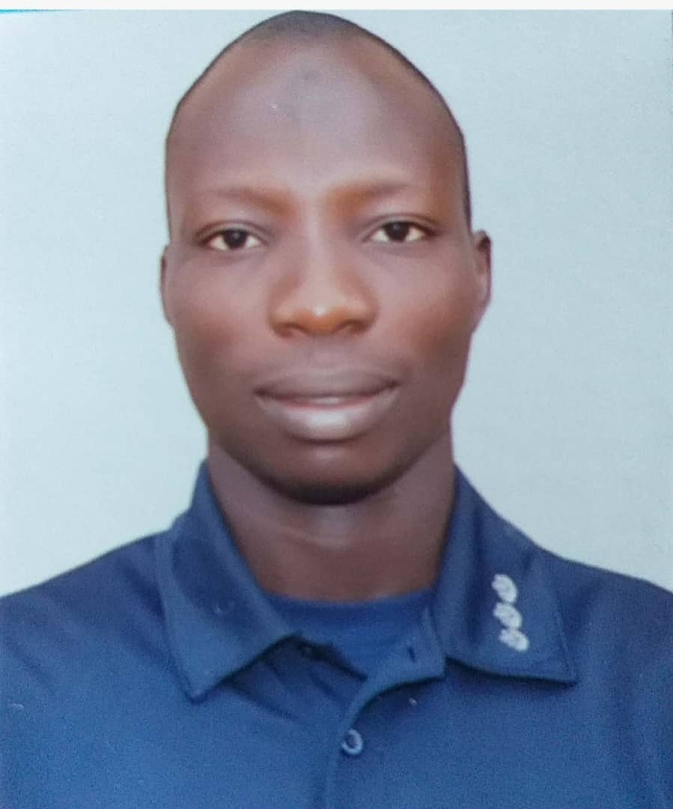
CURRICULUM VITAE

A. PERSONAL DATA
- Full Name: ADEBISI, WARITH ADEWALE
- Date of Birth: 6th March, 1992
- Contact Details:
- Residential Address: No. 12, Big Daddy Area, Osogbo Road, Ila-Orangun
- E-mail Address (es): warith.adebisi@fuhsi.edu.ng
- Mobile Telephone Number(s): +2348149236873
- Nationality: Nigerian
- State of Origin: Oyo
- Local Government Area: Ibarapa Central
- Permanent Home Address: No. 2, Alhaji Adebisi House, Iberekodo, Igboora
- Marital Status: Married
- Number of Children and their Ages: 1 (1 year 6 months)
- Next of Kin: ADEBISI, SURURAT ADEBOYIN
- Contact Details of Next of Kin:
- Residential Address: No. 12, Big Daddy Area, Osogbo Road, Ila-Orangun
- E-mail Address (es): sururatadebayo@gmail.com
- Mobile Telephone Number(s): +2349033779327
- Date of Assumption of Duty: 13th March, 2023
- Rank/Status on First Appointment: Assistant Lecturer
- Present Status: Assistant Lecturer
- Present Salary Grade Level and Step: CONUASS 2 step 2
- Date of Last Promotion/Regrading: Nil
- Faculty/Directorate: Faculty of Science
- Department/Unit: Physical and Chemical Sciences
B. EDUCATIONAL BACKGROUND
- Higher Educational Institutions Attended with Dates:
- University of Ilorin, Ilorin (2016 - 2018)
- Federal University of Agriculture, Abeokuta (2010 - 2014)
- Academic/ Professional Qualifications and Distinctions Obtained with Dates:
- Master of Science (2019)
- Bachelor of Science (2014)

C. WORK EXPERIENCE WITH DATES:
1. Previous Work Experience outside the University System:
(i) Class Teacher, Oyo State Post Primary Schools Teaching Service Commission (OYO TESCOM)
2. Previous Work Experience in Other Universities:
(i) JUPEB Tutor, Centre for Sub and External Degree Programmes, Crescent University, Abeokuta
- Work Experience in FUHSI:
(i) Assistant Lecturer, Federal University of Health Sciences, Ila-Orangun
D. MEMBERSHIP OF PROFESSIONAL BODIES WITH DATES:
Nil

E. PUBLICATIONS:
- Theses/Dissertations:
- Geomagnetic Assessment of Igbeti Marble Deposit. (M. Sc. Thesis). Department of Physics, Faculty of Physical Sciences, University of Ilorin, Nigeria.
- Groundwater Exploration in Igboora, Ibarapa Central Local Government area of Oyo State, Nigeria Using Electrical Resistivity Method. (B.Sc. Research Project). Department of Physics, College of Natural Science, Federal University of Agriculture, Abeokuta, Nigeria.

- Contribution to Books:
- Olatunji, S. & Adebisi, W. (2019). Geomagnetic Assessment of the Igbeti Marble Deposit (Nigeria) In: Doronzo, D., Schingaro, E., Armstrong-Altrin, J., Zoheir, B. (eds). Petrogenesis and Exploration of the Earth’s Interior. CAJG2018. Advances in Science, Technology & Innovation. Springer, Cham. https://doi.org/10.1007/978-3-030-01575-6_66
- Published Journal Articles:
  - Abubakar H. O., Adebisi, W. A., Folorunso, I. O., Olatunji, S. (2024). Integrating aeromagnetic and resistivity data for geologic interpretation of Igbeti schist belt, southwestern Nigeria: Implication for mineral exploration. Ilorin Journal of Science, Vol. 11 No. 3: 189 - 197
  - Adebisi, W. A. & Olatunji S. (2024). . Parameters for Assessing the Subsurface Water Bearing Strata. Big Data in Water Resources Engineering, 5(2): 28-33.

  - Adeojo, T. T., Adebisi, W. A., Aderibaki, A., Adeojo, I. O., Adewumi, O. F. & Amoo, H. B. (2024). Natural radioactivity of drinking water from drilled wells and its consequent radiation dose in Akure south local government area of Ondo state, Nigeria. FUOYE Journal of Pure and Applied Sciences. Vol 9(2), pp 66 – 79.
  - Folorunso, I. O., Adebisi, W. A., Abubakar, H. O. & Olatunji, S. (2024). Identification of tantalite mineralization zones in Igbonla area, North-Central Nigeria using Very Low Frequency Electromagnetic (VLF-EM) techniques. UNIZIK Journal of Engineering and Applied Sciences. 3(3), 1047-1059
  - Adeojo, I. O., Adebisi, W. A., Adeojo, T. T., Adewumi, O. F., Babalola, K. K. & Azeez, S. O. (2023). Radiation Mapping of Osun State, Southwestern Nigeria, measuring the Status of Radioactivity. Fountain Journal of Natural and Applied Sciences. 12(2): 30—37. https://doi.org/10.53704/fujnas.v12i2.471
  - Olatunji, S. & Adebisi, W. A. (2022). Werner Deconvolution Technique for the Interpretation of Residual Aeromagnetic Anomalies of Igbeti Schist Belt; Implication for Marble Exploration. Indonesian Journal on Geosciences, 9 (2): 209 - 217. DOI: 10.17014/ijog.9.2.209-217
  - Olatunji, S., Emiola, A. M., & Adebisi W. A. (2021). Aquifer Vulnerability Evaluation in Southwestern Nigeria from AHP-GODT Model Using Geo-Electrical Derived Parameters. Jurnal Meteorologi Dan Geofisika. Vol 22 No. 1 Tahun 2021: 9-18
  - Olatunji, S. & Adebisi, W. A. (2019). In-situ Assessment of Seasonal Variations of Aquifer Depth in a Part of Basement Rock of North Central Nigeria. Bulletin of the Science Association of Nigeria. Vol 29 (2019) 137 – 148
  - Alabi A. A., Makinde, V., Akinboro, F. G., Adeleke, O. O., Adewale, A. O. & Adebisi, W. A. (2016). Groundwater Exploration in Igboora, Ibarapa Central Local Government Area of Oyo State, Nigeria; Using Electrical Resistivity Method. Published by Nigerian Association of Hydrogeologist. Vol. 26 No.1 and 2. Pp. 33-54.

- Edited Conference Proceedings:
- Refereed:
- Abubakar, H. O., Adebisi, W. A., Folorunso, I. O. & Olatunji, S. (2024). Integrated Aeromagnetic and Resistivity Data for Geologic Interpretation of Igbeti Schist Belt, Southwestern Nigeria: Implication for Mineral Exploration. Faculty of Physical Sciences, University of Ilorin, Nigeria, Maiden International Conference (Hybrid).
- Abubakar, H. O., Adeoye, T. O., Folorunso, I. O. & Adebisi, W. A. (2024). Resistivity Tomography Assessment for Structural Stability around College of Medicine, University of Ilorin. Faculty of Physical Sciences, University of Ilorin, Nigeria, Maiden International Conference (Hybrid).
- Adeojo, T. T., Aderibaki, A., Adebisi, W. A., Adeojo, I. O. & Adewumi, O. F. (2024). Natural Radioactivity of Drinking Water from Drilled Wells and Its Consequent Radiation Dose in Akure South Local Government Area of Ondo State. FUOYE 7th International Science Conference.
- Adeojo, T. T., Adebisi, W. A., Adeojo, I. O. & Adewumi, O. F. (2024). Assessment of Some Widely Consumed Sachet and Bottled Water Brands; Implications for Radiation Risks in Ondo and Ekiti State, South Western Nigeria. NIP 45th Annual Conference.
- Adeniji, Q. A., Odunaike, K., Adelaja, A. D., Adebisi, W. A., Babalola, K. K., Salihu, M. A., Fowodu, T. O., Musa, B., Rabiu, J. A. & Abe, A. O. (2024). NIP 45th Annual Conference.
- Adeniji, Q. A., Rabiu, J. A., Odunaike, K., Rauff, K. O., Abe, A. O., Salihu, M. A., Alfred, D. O., Adelaja, A. D., Adebisi, W. A., Babalola, K. K., Fowodu, T. O. & Muhammad D. M. (2023). Optical Characterization and Profilometric Analysis of Boron Deposited Zinc Selenide (ZnSe:B) Thin Film Via Spray Pyrolysis. International Physical Conference, Federal University Dutsin-Ma.

- Articles Accepted for Publication:
(i) Adeojo, T. T., Adebisi, W. A., Adeojo, I. O., Adewumi, O. F., Babalola, K. K. & Azeez, S. O. (2024). Assessment of Some Widely Consumed Sachet and Bottled Water Brands; Implications for Radiation Risks in Ondo and Ekiti State, South Western Nigeria. Iraqi Journal of Science.

- Manuscripts Submitted for Publication:
- Adebisi, W. A., Folorunso, I. O., Abubakar, H. O., Olatunji, S. & Olaojo, M. O. (2024). Delineating Structural Features Related to Hydrothermal Alterations for Possible Mineralization Within Share Area, Kwara State Nigeria. Submitted to Indonesian Journal of Earth Sciences.
- Folorunso, I. O., Adebisi, W. A., Abubakar, H. O., Olatunji, S., Adeojo, T. T. & Oluwarinde, D. O. (2024). Integrated Geophysical Investigation for Post-Foundation Assessment Within Federal Secretariat Complex, Ilorin, North central Nigeria. Submitted to Indonesian Journal on Geosciences.
- Abubakar, H. O., Adebisi, W. A., Folorunso, I. O., Adeoye, T. O., Olatunji, S. & Odangbe C. (2024). Aquifer Vulnerability Index Model for Vulnerability Assessment: A Case Study of Irewolede Estate in Ilorin, North-Central Nigeria. Submitted to Journal of the Earth and Space Physics
- Abubakar, H. O., Adebisi, W. A., Folorunso, I. O., Adeoye, T. O. & Olatunji, S. (2024). Groundwater Exploration and Vulnerability: A Complrehensive Study on Sustainable Management Strategies in University of Ilorin Teaching Hospital. Submitted to International Journal of Energy and Water Resources.
F. CONFERENCES, SEMINARS AND WORKSHOPS ATTENDED WITH DATES:
(i) Faculty of Physical Sciences, University of Ilorin, Nigeria, Maiden International Conference (Hybrid). 4th – 8th June, 2024.
G. CURRENT RESEARCH ACTIVITIES:
Hydrogeochemistry and Health Risks Assessment of Selected Heavy Metals in Groundwater within the Osun State College of Education Ila-Orangun Campus, Osun State Nigeria

I. OTHER RELEVANT INFORMATION:
1. Services within the Department:
(i) Coordinator, PHY 107, 2022/2023 Session
(ii) Coordinator, PHY 101, 2022/2023, 2023/2024 Session
- Secretary, Departmental Curriculum Drafting Committee
- Member, Departmental Research Committee
2. Services within the University:
(i) Member: Committee on Lecture Monitoring and Quality Assurance on Teaching, Federal University of Health Sciences, Ila-Orangun.
References
- Prof. Saminu Olatunji Department of Geophysics
University of Ilorin,
Ilorin, Kwara State.
Tel: 08032892742
e-mail: sam61ng@gmail.com

- Prof. Victor Makinde Physics Department,
Federal University of Agriculture,
Abeokuta, Ogun State.
Tel: 08035994001
e-mail: victor_makindeii@yahoo.com

- Prof. Rasaq Bello Department of Physics
Federal University of Kashere,
Kashere, Gombe State,
Tel: 08036684498
e-mail: bellorasaq@fukashere.edu.ng

Signature: Date:

